Task - Github

1. <https://github.com/okkyseptian25/training-alterra>
2. New Branch:
   1. development: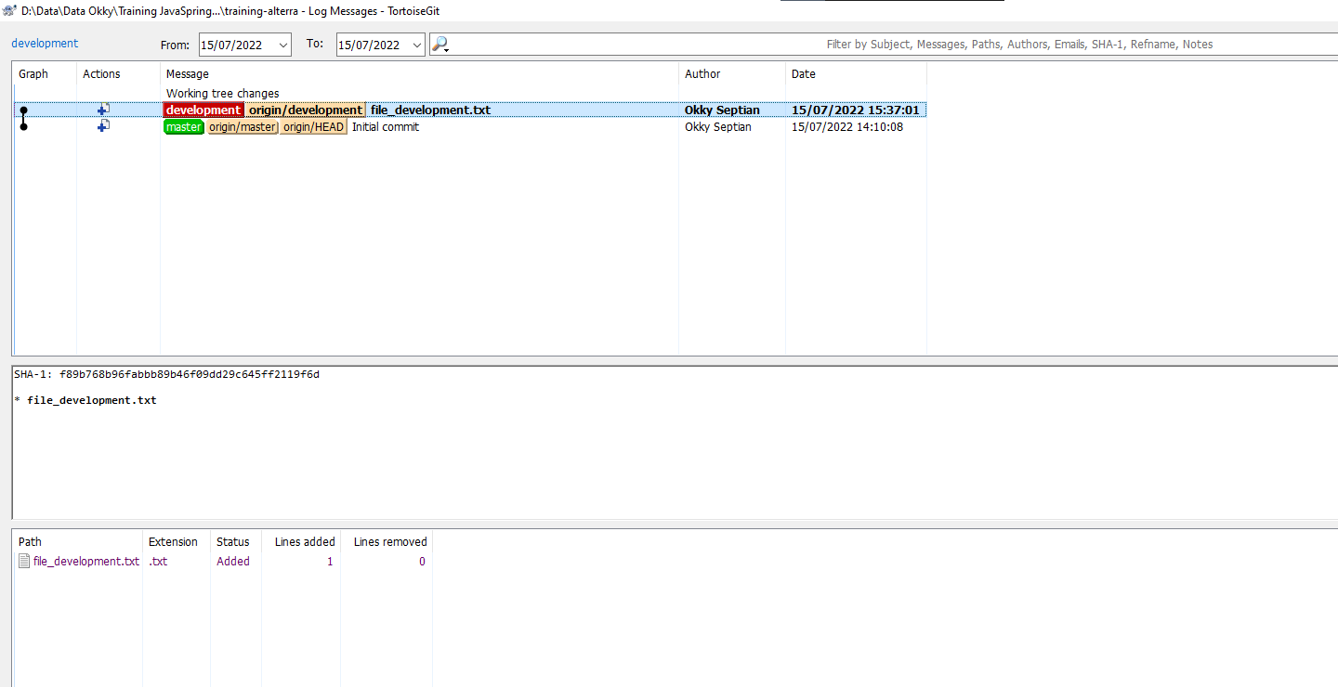
   2. featureA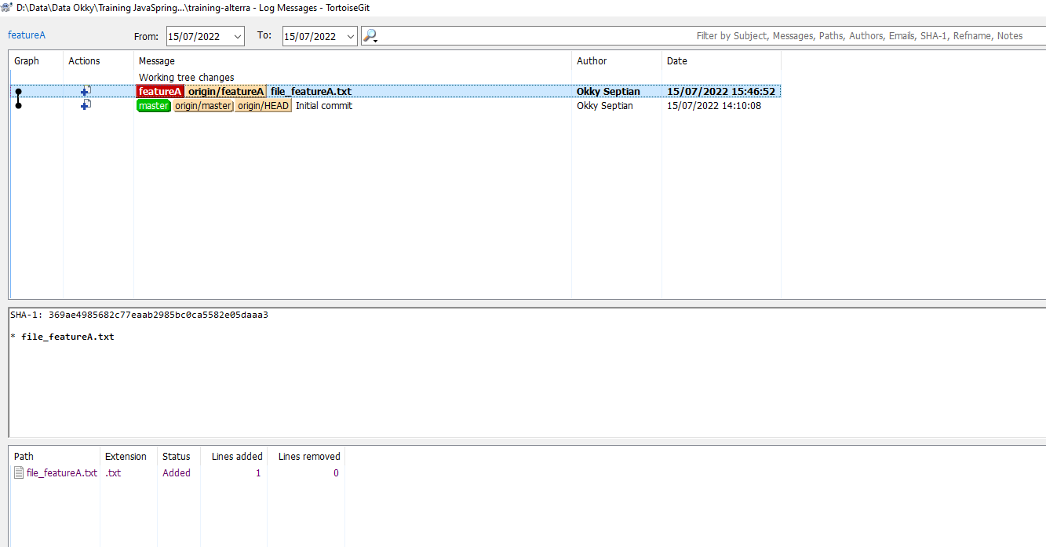
   3. featureB

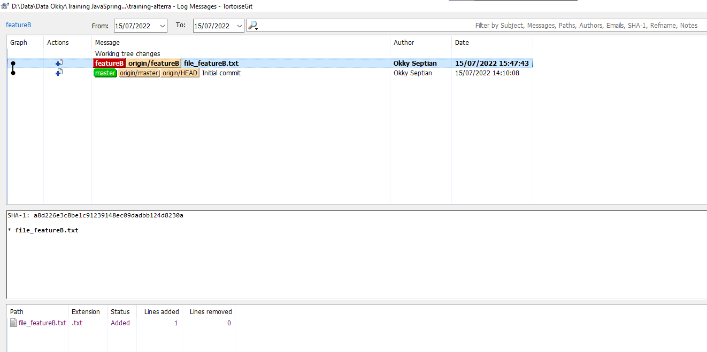

3.

* 1. Push :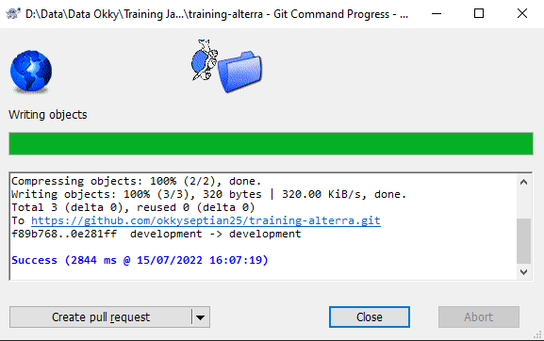
  2. Pull :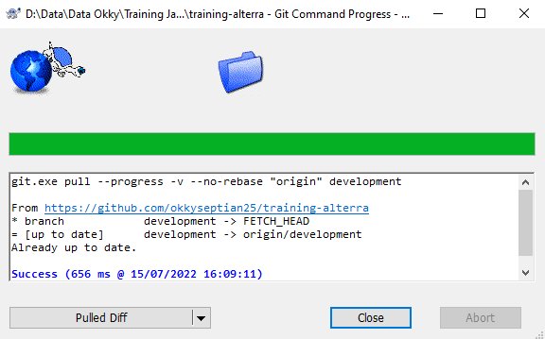
  3. Stash :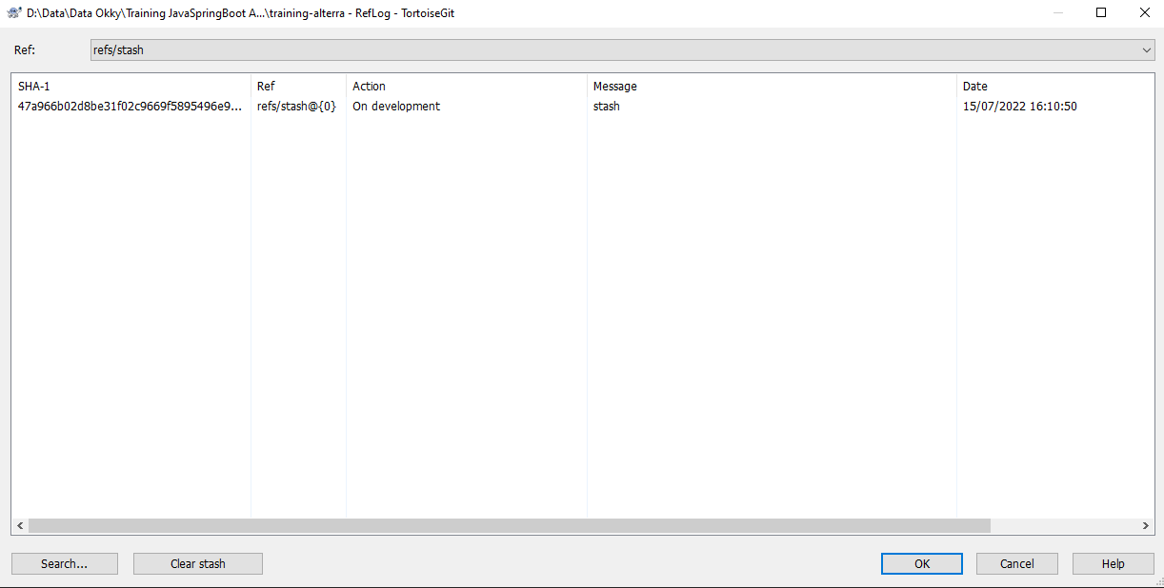
  4. Merge :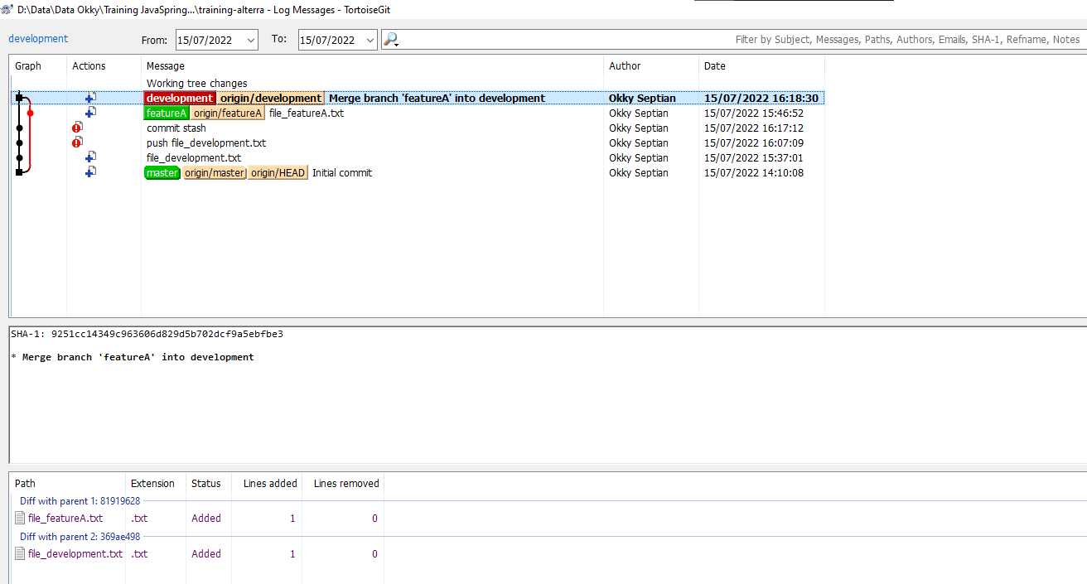

4. Implementasi Conflict saat merge dari featureB :

* merge branch featureB ke branch featureA
* commit dan push branch featureA
* merge featureB ke branch development
* commit dan push branch development
* file_featureB di branch featureA edit di line pertama
* commit dan push branch featureA
* file_featureB di branch featureB edit pada line pertama
* commit dan push branch featureB
* merge dari featureA ke branch development
* commit dan push branch development
* lalu merge juga featureB ke branch development
* akan terjadui conflict karna file featureB di branch development berbeda dengan file featureB pada branch featureB
* Penyelesain masah conflict nya yaitu :

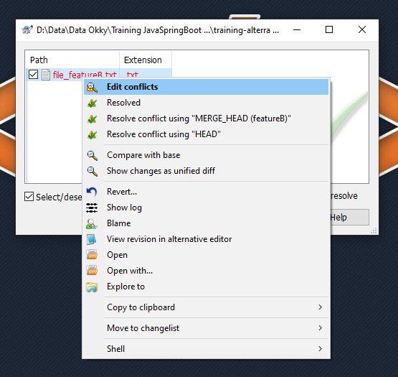

pilih edit conflict, lalu merge manual dengan menggunakan tools beyond compare seperti gambar berikut :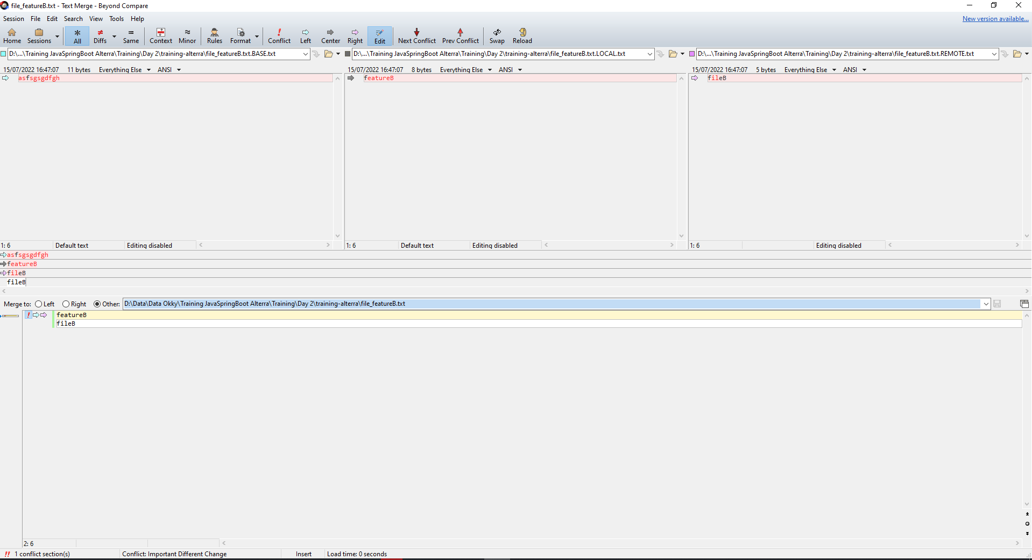

pilih versi mana yg akan di pakai pada file featureB pada branch development tersebut.

Kemudian save file yg sudah di merge manual tersebut, lalu klik resolve seperti pada gambar dibawah ini :

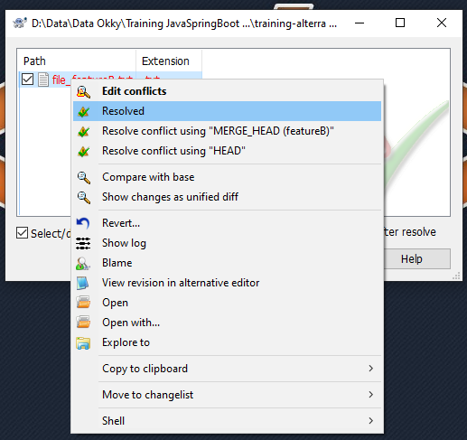

Lalu commit file featureB pada branch development dan push.

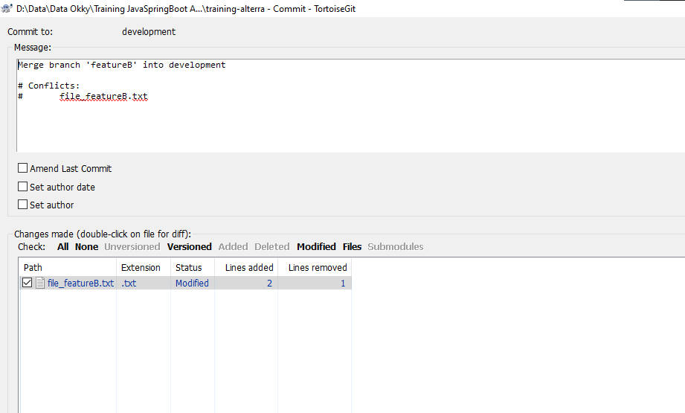

5. Merge no fast forward :

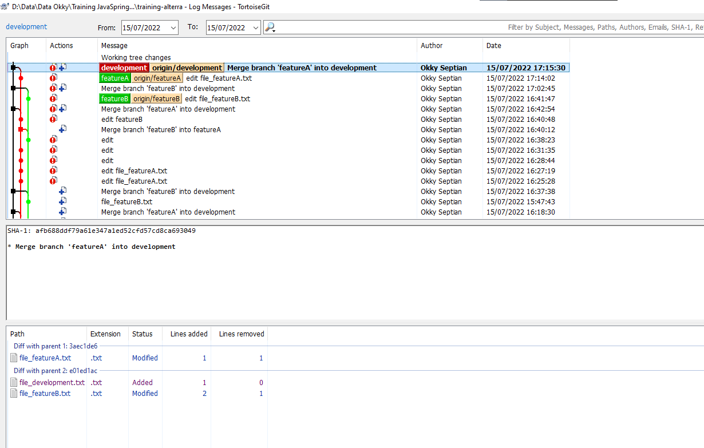

6. Screenshot all branches :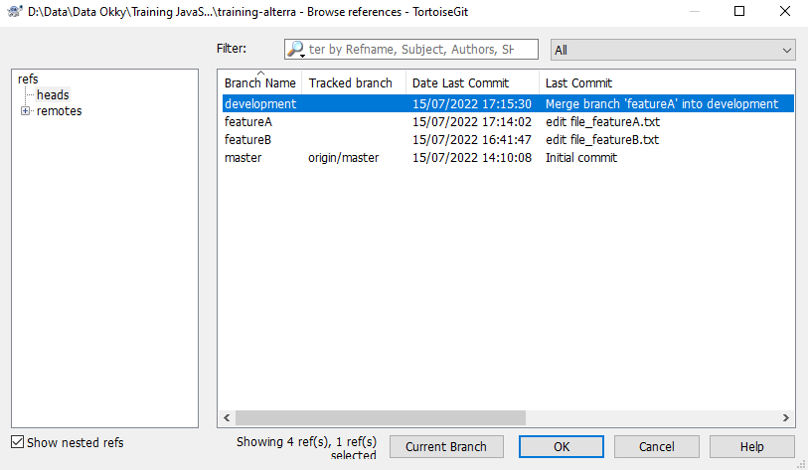

* Branch Development :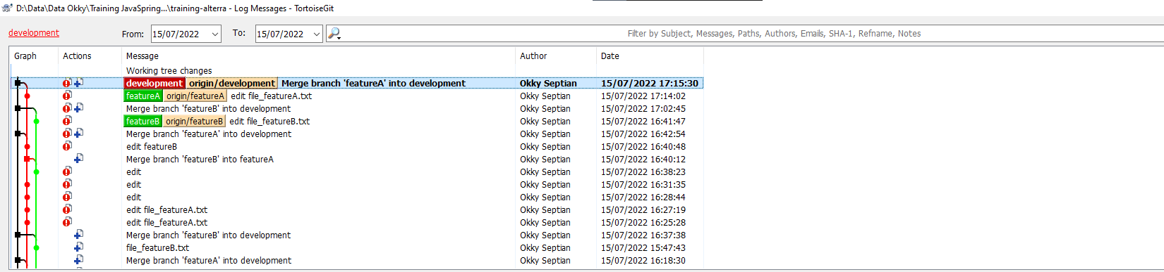
* Branch featureA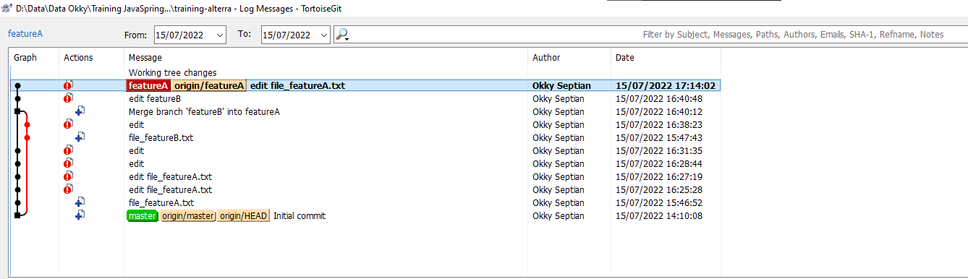
* Branch feature B :